ASSIGHNMENT 1

1) Table “salespeople” ->
Query:
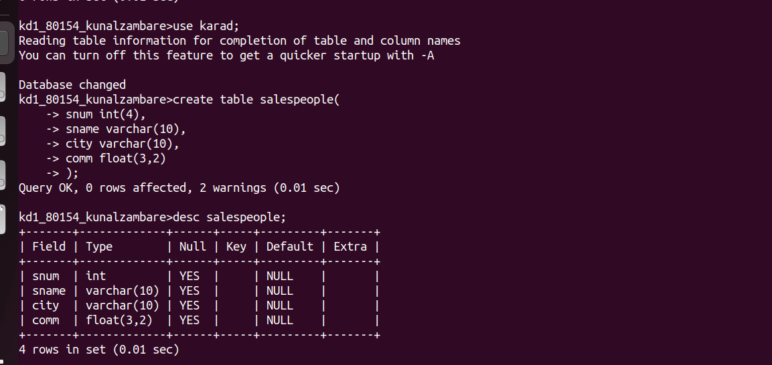
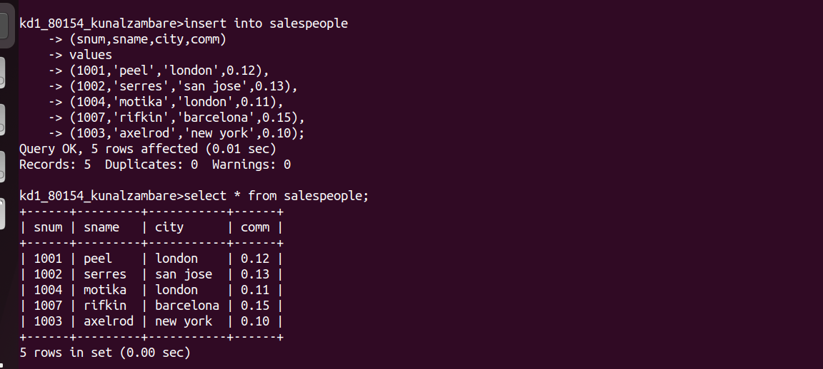

TABLE Sceenshot:

2)”CUSTOMERS” TABLE:

Query:
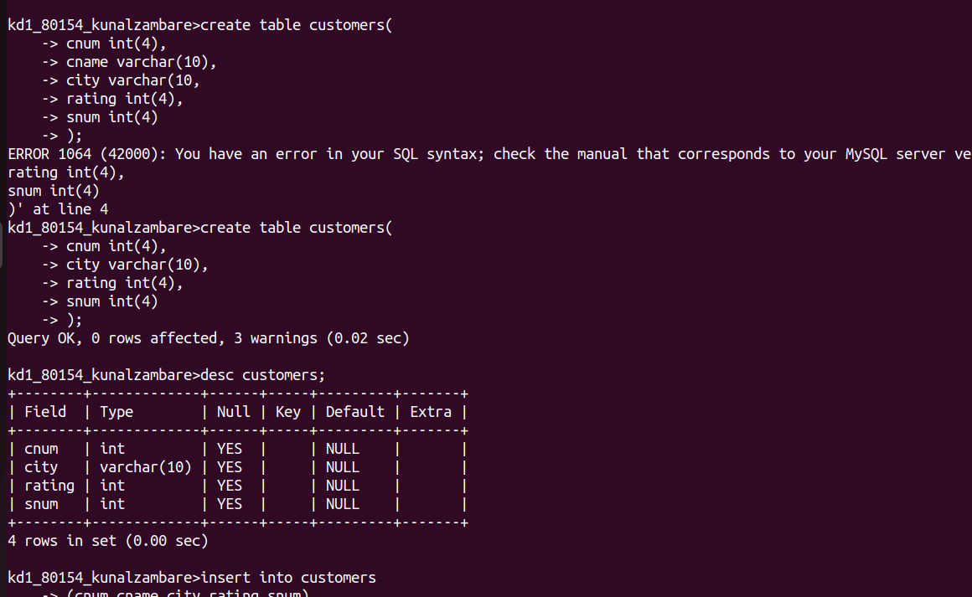

Table Screenshot:



3) Table “ORDERS”:

Query;
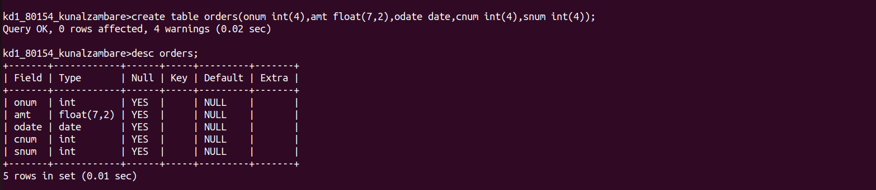




Table Screenshot:
